**FACULTY OF ENGINEERING**

**FORMATTING SENIOR PROJECT REPORT**

1. **Sheet**

The final project report is written on one side of A4 white sheet.

1. **Styling**

Text of the senior project is written in Times New Roman font with 12 font size. A character space is left after a period or comma.

1. **Page Layout**

On A4 size paper, from the left-side 4.0 cm of spacing, from right 2.0 cm of spacing, from top 3.0 cm of spacing, and from bottom 2.5 cm of spacing is left. Figure expressions are placed below of the figure. However, table expressions are placed on top of the table.

1. **Row Spacing**

Text is written with one-line-spacing, but two-line-spacing is left between the paragraphs.

1. **Headings**

Section headings (Preface, Table of Contents, Abstract, Introduction, Appendix, Curriculum vitae) are written in 1st-degree headings.

All titles are written left-justified and numbered accordingly. The headings font style should be as follows:

1. Degree headings; **UPPERCASE LETTER; 12 Font Size, Bold**

  2. Degree headings; **Initials of Words Are Uppercase, 12 Font Size, Bold**

  3. Degree headings; *Initials of Words Are Uppercase, 12 Punto, Italic Letters*

1. **Equations**

Equations are written in the text with a line-spacing both at the top and the bottom.

Moreover, they are written with indentation of 1 cm from the left. Equation numbers are written on the right with an enumeration that is determined with respect to the chapter ( e.g. 4.6, 5.1).

1. **Page Numbers**

All pages, except the outer and inner covers and the signature sheet, contain page numbers at the top of the page as centered.

1. **Citation**

References are given in parentheses as author name and publication year. For example: Özçep (2012) about surfaces …

1. **Style of References**

References are put in alphabetical order according to the surnames of the authors. Journal titles, congress booklet titles or book titles are written in italic font.

For journal articles, surname(s) of the author / authors, initials of the name / names, year of publication, title of the article, title of the journal, volume number (or chapter no) and page numbers are written in this order. An example is given below.

Langel, R. A. and Estes, R. H.,1982, Ageomagneticfieldspectrum, *Geophys. R. Letters,* Vol. 9, No. 4, p. 250-253.

**SENIOR PROJECT**

Your project name should be placed here, ALL letters should be upper case and delete this notification before print this document.

**SAMPLE PROJECT NAME**

Your name and surname should be placed here, FIRST letters should be italic & upper case and delete this notification before print this document.

Submitted by:

*Name Surname*

Your supervisor’s name and surname should be placed here, FIRST letters should be upper case and delete this notification before print this document.

**Titles are;**

Instructor

Dr.Faculty Member

Assoc.Prof.

Professor

Project Supervisor: Title Name Surname

Finishing term of your project should be placed here, FIRST letters should be upper case and delete this notification before print this document. **Examples are;**

Spring 2018

Fall 2019

Spring 2019

Faculty of Engineering

Antalya Bilim University

Spring 2018

**FOREWORD**

Margin from the left is 4 cm and delete this notification before print this document.

Students need an introductory course in computer science that exposes them to all of computer science. Computer science is not just about programming techniques. It rests on deep ideas and the nature of computation. We want students to understand these deep ideas, as well as grasp the practicality of computation and experience the pleasure of computing.

One line space between paragraphs and delete this notification before print this document.

We wrote The Schematics of Computation for one reason---we wanted a book that presents the fundamental ideas of computer science in a way that students can understand. Introductory books in other fields such as physics introduce the areas of the field (mechanics, electricity and magnetism, and optics), while introductory computer science books often have chapters on how to use two-dimensional arrays.

We resolved to write a book that not only gives students essential programming skills, but also provides a vision of what computer science is about. We want to reach those individuals who are already committed to computer science, as well as those who plan to take computer science courses as part of a general education. We hope our enthusiasm for the field will encourage students to pursue advanced studies in computer science.

Margin from the right is 2 cm and delete this notification before print this document.

Margin from the bottom is 2.5 cm and delete this notification before print this document.

This is the last line of this page.

**TABLE OF CONTENTS**

|  |  |
| --- | --- |
| ABSTRACT ……………………………………………………………………... | 3 |
| 1 INTRODUCTION   …………………………………………………………… | 4 |
| 2 DISTRACTED DRIVER DETECTION …………………………………...…. | 12 |
| 2.1 Dataset    ……………………………………………………………...... | 12 |
| 2.1.1 Title of subsubsection ……………………………………………... | 13 |
| 2.1.2 Title of next subsubsection …………………………………….….. | 14 |
| 2.2 Title of Next Subsection  ……………………………………………...... | 14 |
| 3 TITLE OF SECTION (THE INDENTATION EXAMPLE IN A LONG SECTION TITLE) ……………………………………………………………… | 15 |
| 3.1 Title of Another Subsection ………………………………………….… | 16 |
| 3.2 Title of Next Subsection   ……………………………………………… | 18 |
| 4 CONCLUSIONS ……………………………………………………...……… | 20 |
| REFERENCES ………………………………………………………………… | 26 |

**ABSTRACT**

Margin from the top is 3.0 cm and delete this notification before print this document.

Every year, many car accidents due to driver fatigue and distraction occur around the world and cause many casualties and injuries. Engineers and researchers in the automobile industry have tried to design and build safer automobiles, but traffic accidents are unavoidable. As Computer Engineers, if we deeply investigated the causes of these accidents, we will find that these behavioral and roadway accident patterns can be useful to develop traffic safety control policies.

Margin from the left is 4.0 cm and delete this notification before print this document.

One line space between paragraphs and delete this notification before print this document.

We believe that to obtain the greatest possible accident reduction effects with limited budgetary resources, it is important that measures be based on scientific and objective surveys of the causes of accidents and severity of injuries.

This paper is about how to address this problem by Internet of Things and machine learning, two technologies that are taking the world by storm and will someday become an inherent part of every aspect of our lives.

Margin from the right is 2.0 cm and delete this notification before print this document.

Margin from the bottom is 2.5 cm and delete this notification before print this document.

This is the last line of this page.

**1 INTRODUCTION**

1st degree headings should be ALL CAPS, **bold**, 12pts and font is Times New Roman, FIRST letters should be upper case and delete this notification before print this document.

The transportation industry is associated with high maintenance costs, disasters, accidents, injuries and loss of life. Hundreds of thousands of people across the world are losing their lives to car accidents and road disasters every year. According to the World Health Organization, there were 1.25 million road traffic deaths globally in 2013.

The related costs were estimated at $152 billion. And this doesn’t account for general maintenance and repairs costs of the road and highway systems, which earmark billions of dollars of public funds every year and are still underfunded.

2nd degree headings should be **bold**, 12pts and font is Times New Roman, FIRST letters should be upper case and delete this notification before print this document.

These statistics motivated us to work on developing a System that helps in reducing the amount of car accidents around the world, where There are several approaches that researchers have employed to study this problem. These include neural network and so on. Thus, detecting the driver's state is the beginning of our journey, where more than a quarter of all car crashes in America are likely caused by cell phone use.

Citations should be in this form; Author Surname and in paranthesis publication year.

**Examples are**; Özcep (2012), Langel (1982)

Delete this notification before print this document.

**2 DISTRACTED DRIVER DETECTION**

**2.1 Dataset**

The used dataset in our project was supplied by Langel (1982) and a challenge on the Kaggle platform, the name of the challenge is “State Farm Distracted Driver Detection”, the given Dataset is about driver images, each taken in a car with a driver doing something in the car (texting, eating, talking on the phone, makeup, reaching behind, etc).

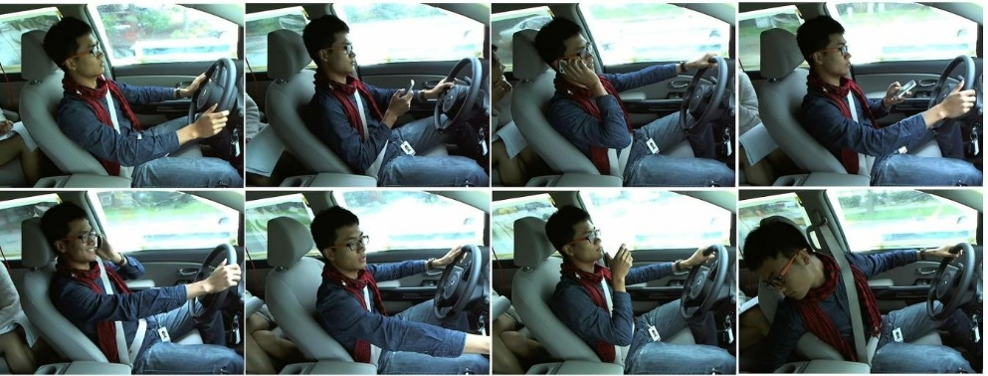The dataset consists of 22400 training and 79727 testing images (640 × 480 full color) of people either driving safely or doing one of eight kinds of distracted behaviors.

3rd degree headings should be *italic*, 12pts and font is Times New Roman, Keyword initials should be upper case and delete this notification before print this document.

Figure 1 – A sample of Dataset

*2.1.1 Sub Section*

These statistics motivated us to work on developing a system that helps in reducing the amount of car accidents around the world, where There are several approaches that researchers have employed to study this problem. These include neural network and so on.

These statistics motivated us to work on developing a System that helps in reducing

Margin from the bottom is 2.5 cm and delete this notification before print this document.

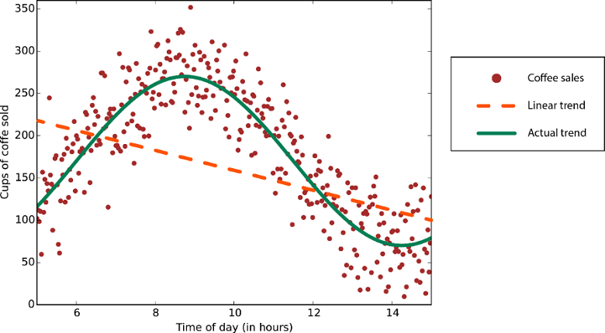

Figures should be centered and named below and Figure titles should be centered and named with numbers and delete this notification before print this document.

Figure 2 – A graph

Equations should be centered, Equation titles should be right-aligned and a blank line should be left before & after the equation and delete this notification before print this document.

C=12n∑x‖y(x)−aL(x)‖2

Equation 1 – Sum

Tables should be centered and named below and Table titles should be centered and named with numbers and delete this notification before print this document.

|  |  |  |  |  |
| --- | --- | --- | --- | --- |
| Model | F1-Score | Top-1 Accuracy | Top-2 Accuracy | Loss |
| VGG16 +  CrossValidation | 99% | 96.2226% | 98.8833% | 0.14280 |
| InceptionV3 + CrossValidation | 99% | 95.4531% | 97.9350% | 0.20000 |
| ResNet50 + CrossValidation | 98% | 96.6773% | 98.7186% | 0.12851 |
| Xception + CrossValidation | 98% | 94.1785% | 96.8790% | 0.30539 |
| ResNet50 + VGG16 | 99% | 96,4499% | 98,8008% | 0.13565 |
| VGG16 +  inceptionV3+Res Net50+Xception | 99% | 96.3080% | 98.1039% | 0.23126 |

Figures should be centered and named below and Figure titles should be centered and named with numbers and delete this notification before print this document.

Table 1 – Results

**REFERENCES**

References should be listed in alphabetical order and be written in this order; author’s surname, initials of name/names, publication

year, the name of the article, the name of the article, the volume number (or chapter no), the page number.   
  
Delete this notification before print this document.

Angel, R. A. and Estes, R. H.,1982, Ageomagneticfieldspectrum, Geophys. R. Letters,Vol. 9,No. 4, p. 250-253.

Langel, R. A. and Estes, R. H.,1982, Ageomagneticfieldspectrum, Geophys. R. Letters,Vol. 9,No. 4, p. 250-253.